*# Assignment 3B*

*# get the path for the working directory*

[**getwd**](http://inside-r.org/r-doc/base/getwd)()

*#set the working directory by assigning the path for the file*

[**setwd**](http://inside-r.org/r-doc/base/setwd)("C:/Users/Neha/Desktop")

*#load the csv file*

BirdStrikes<-[**read.csv**](http://inside-r.org/r-doc/utils/read.csv)("Bird Strikes.csv", header = T, sep = ",", [**quote**](http://inside-r.org/r-doc/base/quote)="**\"**")

Bird.data.new <- [**read.table**](http://inside-r.org/r-doc/utils/read.table)("Bird Strikes.csv", header = T, sep = ",", [**quote**](http://inside-r.org/r-doc/base/quote) = "**\"**", fill = T)

# get the path of the working directory

# set the working directory by assigning the path of the file

# load the CSV file

**Problem 1**

*# Problem 1*

*# Defining the function UnReportedStrikes: to obtain the bird strikes not reported*

*# Input for this function is Bird Strikes data file*

UnReportedStrikes <- [**function**](http://inside-r.org/r-doc/base/function) (UnReportedStrikes) {

*# obtaining the total no of unreported strikes from the appropriate column*

UnReportedStrikes <-[**sum**](http://inside-r.org/r-doc/base/sum)(UnReportedStrikes$Reported=="")

*# To get the output as the sum of total no of unreported bird strikes*

[**cat**](http://inside-r.org/r-doc/base/cat)("The number of bird strikes which were unreported are")

[**cat**](http://inside-r.org/r-doc/base/cat)("**\n**")

[**print**](http://inside-r.org/r-doc/base/print)(UnReportedStrikes)

}

UnReportedStrikes(Bird.data.new)

**Stratergy**:

1. *Defining the function UnReportedStrikes: to obtain the bird strikes not reported*
2. *Input for this function is Bird Strikes data file*
3. *obtaining the total no of unreported strikes from the appropriate column*
4. *To get the output as the sum of total no of unreported bird strikes*

**Output:** Output is the number of bird strikes which were reported

> UnReportedStrikes(Bird.data.new)

The number of bird strikes which were unreported are

[1] 71537

***# Problem 2***

*#Defining the function: MostBirdStrikes to obtain the year which had the most number of bird strikes*

*# Input for this function is the Bird Strikes data*

MostBrirdStrikes<- [**function**](http://inside-r.org/r-doc/base/function)(birdstrikescount_year) {

Bird.Strike.data <- birdstrikescount_year

*# Reading the dates to get the desired output*

birdstrikes_date<-**[as.Date](http://inside-r.org/r-doc/base/as.Date)**(Bird.Strike.data$FlightDate, [**format**](http://inside-r.org/r-doc/base/format)="%m/%d/%Y")

*# obtaining the desired format for the dates*

birdstrikescount_year<-[**table**](http://inside-r.org/r-doc/base/table)([**format**](http://inside-r.org/r-doc/base/format)(birdstrikes_date, "%Y"))

*# arranging the table in decending order*

birdstrikescount_year<-[**sort**](http://inside-r.org/r-doc/base/sort)( birdstrikescount_year,dec = T)

*# To get the output and printing it out*

[**cat**](http://inside-r.org/r-doc/base/cat)("The year that had the most Bird Strikes was")

[**cat**](http://inside-r.org/r-doc/base/cat)("**\n**")

[**print**](http://inside-r.org/r-doc/base/print)(birdstrikescount_year[1])

}

 MostBrirdStrikes(Bird.data.new)

**Stratergy:**

1. *Defining the function: MostBirdStrikes to obtain the year which had the most number of bird strikes*
2. *Input for this function is the Bird Strikes data*
3. *Reading the dates to get the desired output*
4. *obtaining the desired format for the dates*
5. *arranging the table in decending order*
6. *To get the output and printing it out*

**Output:**

The year that had the most Bird Strikes

> MostBrirdStrikes(Bird.data.new)

The year that had the most Bird Strikes was

2010

10923

***# Problem 3***

*# Definig the function: StrikesInAYear to count the total number of strikes per year*

*# Input for the function is the Bird Strike data file*

StrikesInAYear <- [**function**](http://inside-r.org/r-doc/base/function) (BirdStrikesPerYear) {

*# to get the desired column from the data set*

Strike.year.data <- BirdStrikesPerYear

BirdStrikesPerYear <- [**as.Date**](http://inside-r.org/r-doc/base/as.Date)(Strike.year.data$FlightDate, [**format**](http://inside-r.org/r-doc/base/format)="%m/%d/%Y")

*# arranging the obtained data into a tabular column*

BirdStrikes.Per.Year <- [**table**](http://inside-r.org/r-doc/base/table)([**format**](http://inside-r.org/r-doc/base/format)(BirdStrikesPerYear, "%Y"))

*# Placing the results in a Data Frame*

BirdStrikesPerYear.data <- [**as.data.frame**](http://inside-r.org/r-doc/base/as.data.frame)(BirdStrikes.Per.Year)

*# TO get the output and print results*

[**cat**](http://inside-r.org/r-doc/base/cat)("Number of Bird Strikes for each year in a Data Frame")

[**cat**](http://inside-r.org/r-doc/base/cat)("**\n**")

[**print**](http://inside-r.org/r-doc/base/print)(BirdStrikesPerYear.data)

}

StrikesInAYear(Bird.data.new)

**Stratergy:**

1. *Definig the function: StrikesInAYear to count the total number of strikes per year*
2. *Input for the function is the Bird Strike data file*
3. *to get the desired column from the data set*
4. *arranging the obtained data into a tabular column*
5. *Placing the results in a Data Frame*
6. *TO get the output and print results*

**Output:**

The no of strikes for each year in Data Frame

|  |
| --- |
| > StrikesInAYear(Bird.data.new)  Number of Bird Strikes for each year in a Data Frame  Var1 Freq  1 2000 6407  2 2001 6287  3 2002 6769  4 2003 6664  5 2004 7667  6 2005 7804  7 2006 8010  8 2007 8746  9 2008 8903  10 2009 10741  11 2010 10923  12 2011 10483 |
|  |
| |  | | --- | |  | |

*#* ***Problem 4***

*# Defining function AirlineWithMOstStrike*

*# Input for the function would be Bird Strike data*

AirlineWithMostStrike <- [**function**](http://inside-r.org/r-doc/base/function)(Maxstrikes){

Maxstrikes.data <- Maxstrikes

*# to get the data from data set*

Max.Strikes <- [**table**](http://inside-r.org/r-doc/base/table)(Maxstrikes.data[15])

*#view(Max.Strikes)*

[**print**](http://inside-r.org/r-doc/base/print)(Max.Strikes)

*# To Storing the function in a variable and printing in the next line*

MaxBirdStrikes(Max.Strikes)

}

*# defining function MaxBirdStrikes to pass the data frame generated in the above function*

MaxBirdStrikes <- [**function**](http://inside-r.org/r-doc/base/function)(Max.Strikes){

*# placing the reults in a data frame*

MaxStrikes.Data.Frame <- Max.Strikes

MaxStrikesDataFrame <- [**as.data.frame**](http://inside-r.org/r-doc/base/as.data.frame)(MaxStrikes.Data.Frame)

*#To sort the data frame in decreasing order*

MaxNoAirlines<- MaxStrikesDataFrame[**[with](http://inside-r.org/r-doc/base/with)**(MaxStrikesDataFrame, [**order**](http://inside-r.org/r-doc/base/order)(-Freq)), ]

*# To get the second max strikes as the first might have missing values*

SecondMaxStrikes<- MaxNoAirlines[2,]

*# get the output and print the output*

[**cat**](http://inside-r.org/r-doc/base/cat)("The airline that has the maximum bird strike without missing values in it")

[**cat**](http://inside-r.org/r-doc/base/cat)("**\n**")

[**print**](http://inside-r.org/r-doc/base/print)(SecondMaxStrikes)

}

AirlineWithMostStrike(Bird.data.new)

**Stratergy:**

1. *Defining function AirlineWithMOstStrike*
2. *Input for the function would be Bird Strike data*
3. *to get the data from data set*
4. *placing the reults in a data frame*
5. *To Storing the function in a variable and printing in the next line*
6. *defining function MaxBirdStrikes to pass the data frame generated in the above function*
7. *placing the reults in a data frame*
8. *To sort the data frame in decreasing order*
9. *To get the second max strikes as the first might have missing values* *get the output and print the output*

**Output:**

The airline that has the maximum bird strike without missing values in it

> AirlineWithMostStrike(Bird.data.new)

The airline that has the maximum bird strike without missing values in it

Var1 Freq

241 MILITARY 9193

**Problem 5**

Time Complexity based on graphs and Regression line

The analysis shows that for the input size for different funtions increases linearly, the time complexity would be linearly dependent.

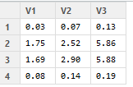

*The above matrix shows that al the data obtained is linealy dependent and has been increasing similarly*

*For problem 1 :*

*We can see that the values increase linearly with input size. The time complexity would be O(n)*

*For problem 2:*

*We can see that the values increase linearly with input size. The time complexity would be O(n)*

*For problem 3:*

*We can see that the values increase linearly with input size. The time complexity would be O(n)*

*For problem 4:*

*We can see that the values increase linearly with input size. The time complexity would be O(n)*

*As it is increasing linearly for all input sizes it would also increase for 2X, 10X, 100X, 1000X*

Space Complexity based on graphs and Regression line:

The analysis shows that for the input size for different funtions increases linearly, the space complexity would be linearly dependent.

*For all the problem 1 to 4*

*The memory size increses linearly, the space complexity would also increase linearly.*

***# Problem 6***

*# double the input size*

[**double**](http://inside-r.org/r-doc/base/double) <- [**rbind**](http://inside-r.org/r-doc/base/rbind)(Bird.data.new,Bird.data.new)

*#quadraple the input size*

quad <- [**rbind**](http://inside-r.org/r-doc/base/rbind)(**[double](http://inside-r.org/r-doc/base/double)**,[**double**](http://inside-r.org/r-doc/base/double))

*# put all kinds of input sizes into a data object*

DataObject <- [**list**](http://inside-r.org/r-doc/base/list)(Bird.data.new,[**double**](http://inside-r.org/r-doc/base/double),quad)

*#give the matrix of all the outputs from the loop*

[**time**](http://inside-r.org/r-doc/stats/time) <- [**matrix**](http://inside-r.org/r-doc/base/matrix)(**[nrow](http://inside-r.org/r-doc/base/nrow)**=4,[**ncol**](http://inside-r.org/r-doc/base/ncol) =[**length**](http://inside-r.org/r-doc/base/length)(DataObject))

**for**(i **in** 1: [**length**](http://inside-r.org/r-doc/base/length)(DataObject)){

*#calculate elapsed time for different sizes of input for a mentioned function*

[**time**](http://inside-r.org/r-doc/stats/time)[1,i] <- [**system.time**](http://inside-r.org/r-doc/base/system.time)(UnReportedStrikes(DataObject[[i]]))[3]

*#calculate elapsed time for different sizes of input for a mentioned function*

[**time**](http://inside-r.org/r-doc/stats/time)[2,i] <- [**system.time**](http://inside-r.org/r-doc/base/system.time)(MostBrirdStrikes(DataObject[[i]]))[3]

*#calculate elapsed time for different sizes of input for a mentioned function*

[**time**](http://inside-r.org/r-doc/stats/time)[3,i] <- [**system.time**](http://inside-r.org/r-doc/base/system.time)(StrikesInAYear(DataObject[[i]]))[3]

*#calculate elapsed time for different sizes of input for a mentioned function*

[**time**](http://inside-r.org/r-doc/stats/time)[4,i] <- [**system.time**](http://inside-r.org/r-doc/base/system.time)(AirlineWithMostStrike(DataObject[[i]]))[3]

}

[**View**](http://inside-r.org/r-doc/utils/View)([**time**](http://inside-r.org/r-doc/stats/time))

*#give sizes of input data*

DataSize = [**c**](http://inside-r.org/r-doc/base/c)(1,2,4)

*#plot and check the effect of different input sizes on time complexity for function UnReportedStrikes and then plot a regression line*

function1 <- [**plot**](http://inside-r.org/r-doc/graphics/plot)(DataSize,[**time**](http://inside-r.org/r-doc/stats/time)[1,],type="b", main = "UnReportedStrikes", xlim = [**c**](http://inside-r.org/r-doc/base/c)(0.5,4.5), ylim = [**c**](http://inside-r.org/r-doc/base/c)(0.03,0.13), xlab = "Data size", ylab = "elapsed time")

[**abline**](http://inside-r.org/r-doc/graphics/abline)([**lm**](http://inside-r.org/r-doc/stats/lm)([**time**](http://inside-r.org/r-doc/stats/time)[1,]~DataSize), [**col**](http://inside-r.org/r-doc/base/col)="blue")

*#plot and check the effect of different input sizes on time complexity for function MostBrirdStrikes and then plot a regression line*

function2 <- [**plot**](http://inside-r.org/r-doc/graphics/plot)(DataSize,[**time**](http://inside-r.org/r-doc/stats/time)[2,],type="b",, main = "MostBrirdStrikes", xlim = [**c**](http://inside-r.org/r-doc/base/c)(0.5,4.5), ylim = [**c**](http://inside-r.org/r-doc/base/c)(1.64,5.8), xlab = "Data size", ylab = "elapsed time")

[**abline**](http://inside-r.org/r-doc/graphics/abline)([**lm**](http://inside-r.org/r-doc/stats/lm)([**time**](http://inside-r.org/r-doc/stats/time)[2,]~DataSize), [**col**](http://inside-r.org/r-doc/base/col)="blue")

*#plot and check the effect of different input sizes on time complexity for function StrikesInAYear and then plot a regression line*

function3 <- [**plot**](http://inside-r.org/r-doc/graphics/plot)(DataSize,[**time**](http://inside-r.org/r-doc/stats/time)[3,],type="b", main = "StrikesInAYear", xlim = [**c**](http://inside-r.org/r-doc/base/c)(0.5,4.5), ylim = [**c**](http://inside-r.org/r-doc/base/c)(1.5,5.8), xlab = "Data size", ylab = "elapsed time")

[**abline**](http://inside-r.org/r-doc/graphics/abline)([**lm**](http://inside-r.org/r-doc/stats/lm)([**time**](http://inside-r.org/r-doc/stats/time)[3,]~DataSize), [**col**](http://inside-r.org/r-doc/base/col)="blue")

*#plot and check the effect of different input sizes on time complexity for function AirlineWithMostStrike and then plot a regression line*

function4 <- [**plot**](http://inside-r.org/r-doc/graphics/plot)(DataSize,[**time**](http://inside-r.org/r-doc/stats/time)[4,],type="b", main = "AirlineWithMostStrike", xlim = [**c**](http://inside-r.org/r-doc/base/c)(0.5,4.5), ylim = [**c**](http://inside-r.org/r-doc/base/c)(0.08,0.20), xlab = "Data size", ylab = "elapsed time")

[**abline**](http://inside-r.org/r-doc/graphics/abline)([**lm**](http://inside-r.org/r-doc/stats/lm)([**time**](http://inside-r.org/r-doc/stats/time)[4,]~DataSize), [**col**](http://inside-r.org/r-doc/base/col)="blue")

**Stratergy:**

1. *double the input size*
2. *quadraple the input size*
3. *put all kinds of input sizes into a data object*
4. *give the matrix of all the outputs from the loop*
5. *calculate elapsed time for different sizes of input for a mentioned function*
6. *calculate elapsed time for different sizes of input for a mentioned function*
7. *calculate elapsed time for different sizes of input for a mentioned function*
8. *calculate elapsed time for different sizes of input for a mentioned function*
9. *give sizes of input data*
10. *plot and check the effect of different input sizes on time complexity for function UnReportedStrikes and then plot a regression line*
11. *plot and check the effect of different input sizes on time complexity for function MostBrirdStrikes and then plot a regression line*
12. *plot and check the effect of different input sizes on time complexity for function StrikesInAYear and then plot a regression line*
13. *plot and check the effect of different input sizes on time complexity for function AirlineWithMostStrike and then plot a regression line*

Result:

The following graphs were obtained

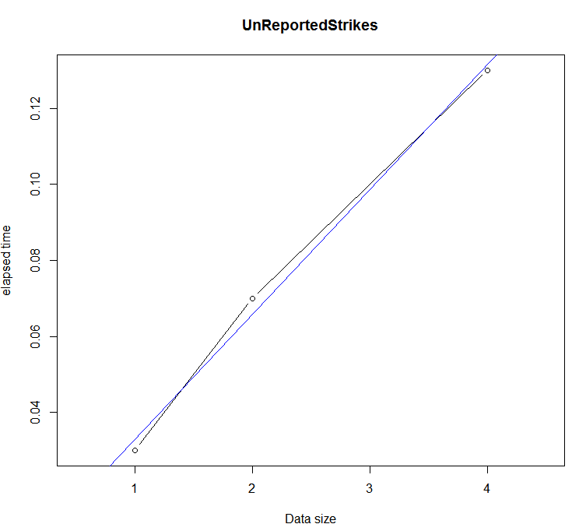

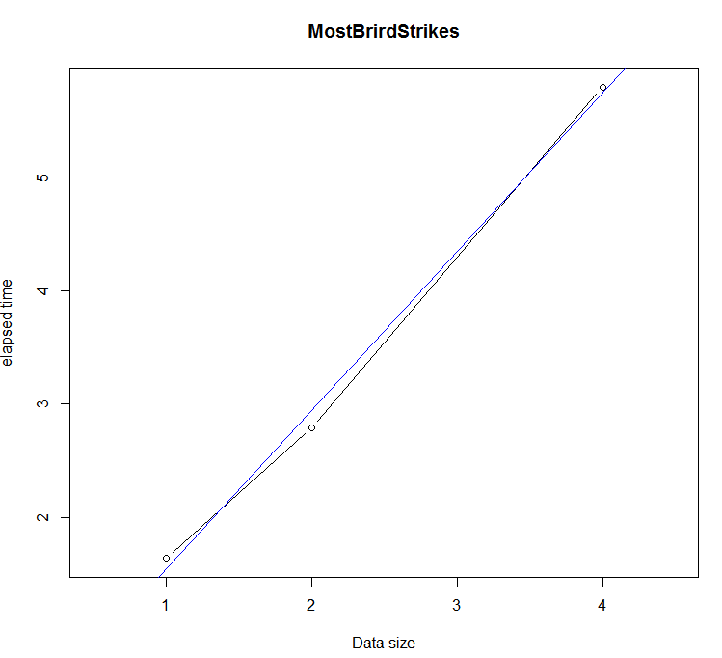

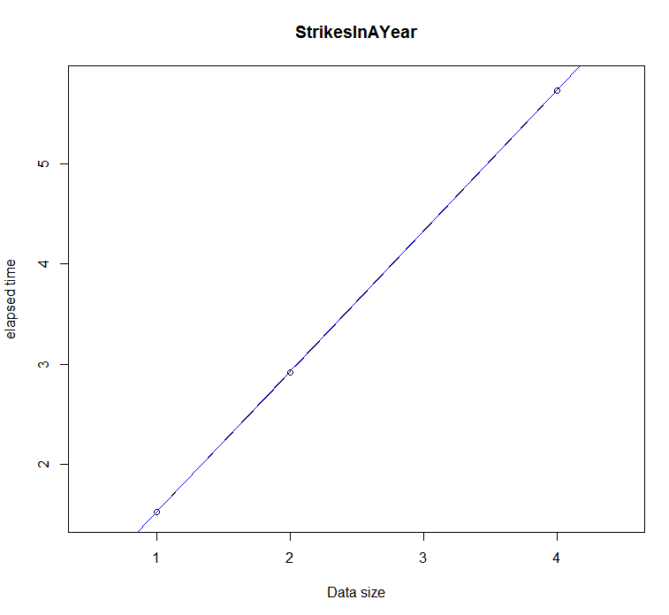

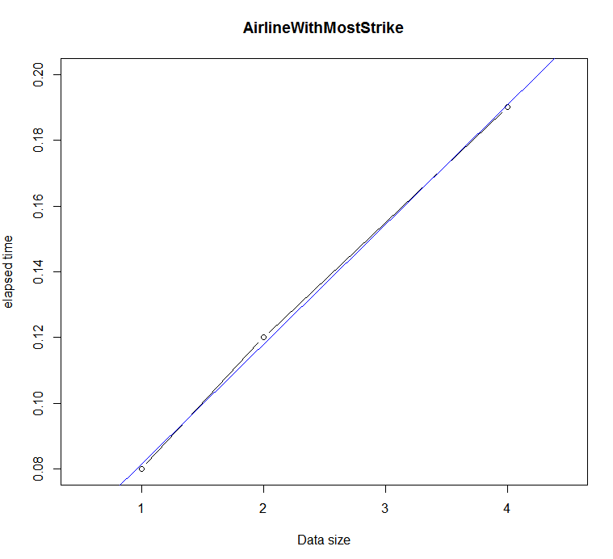

From the graphs above we can summarize that the growth og the function is linearly dependent